Principle of Data Base Management Systems

Prashanth.S(19MID0020**)**

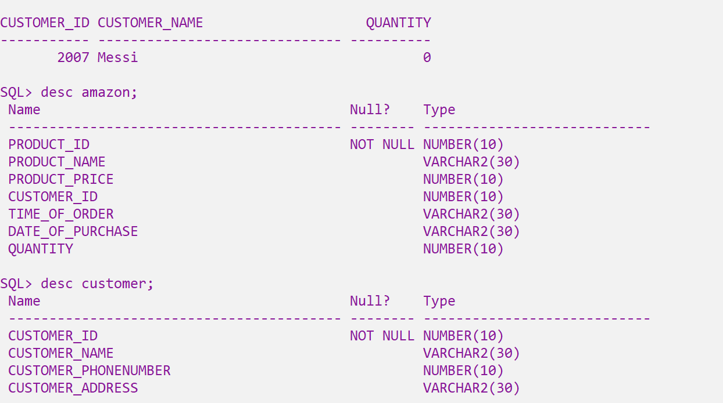

**Amazon table**

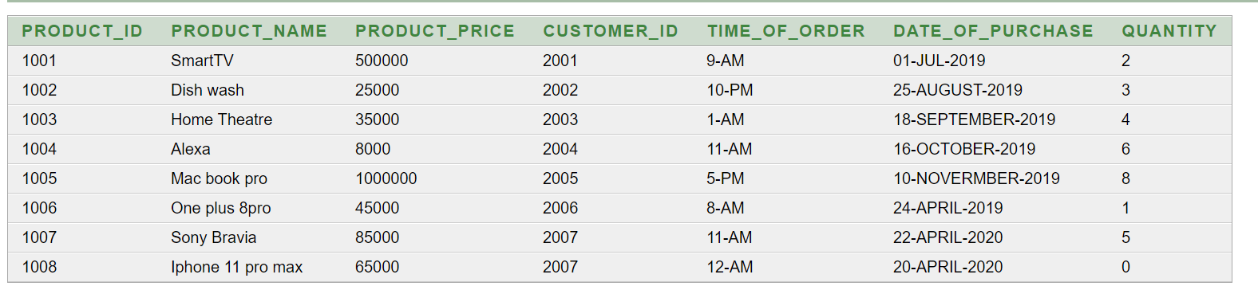

**Customer table**

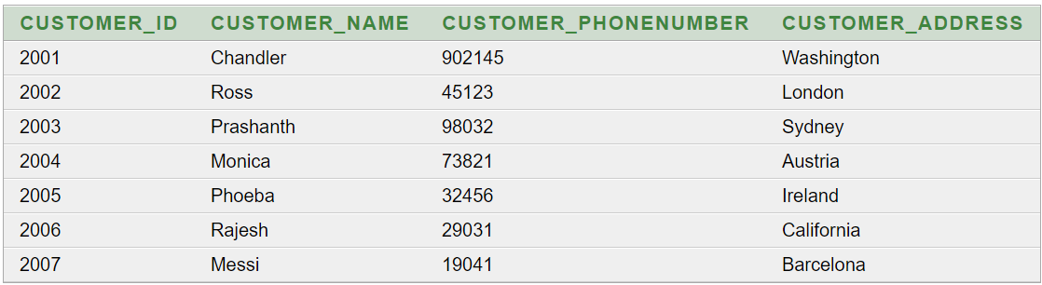

**Joints**

1)Find the names of product whose customer location is ‘London’ ??  
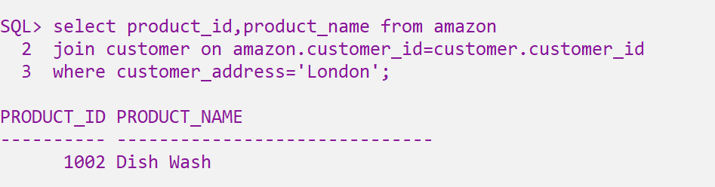

2)Find customer who purchased maximum quantity of product  
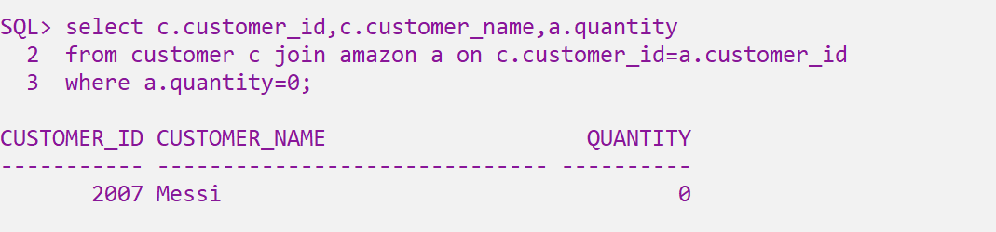

3) Find the customer who spent maximum amount in the shopping  
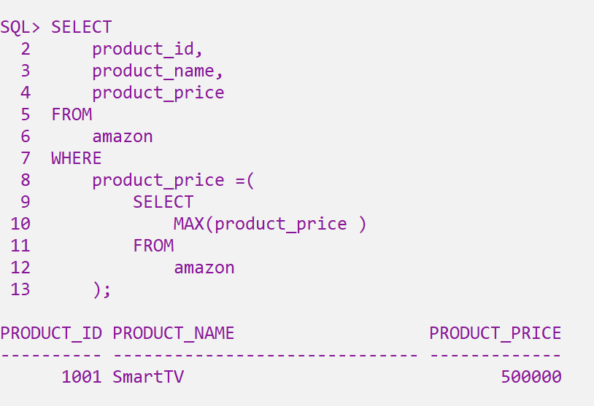

4) Find the name of the customer who brought the maximum number of products.

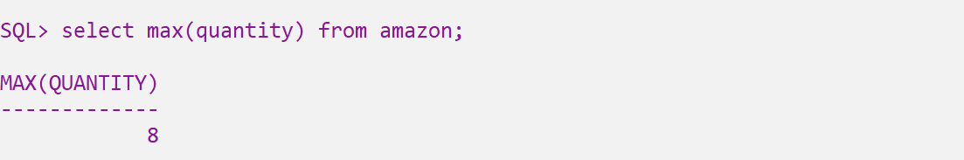

After knowing the maximum quantity

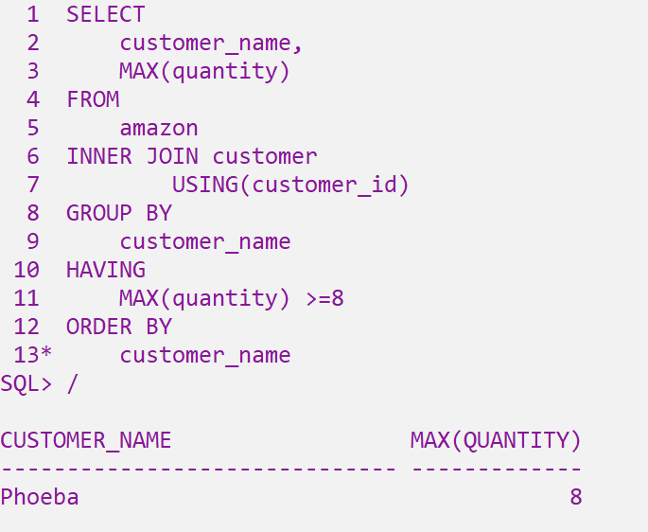

5) List the customer who didn’t buy anything.

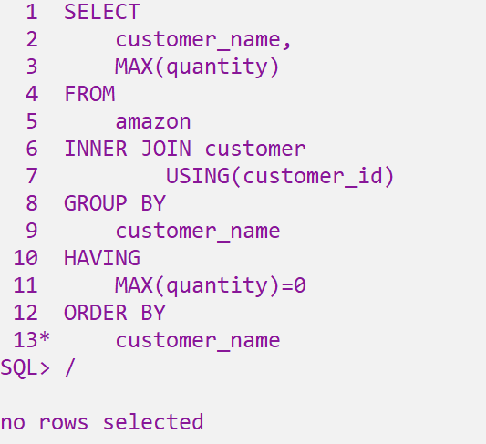

6) Display the name of the customers who brought 3,4,5 quantity of products??

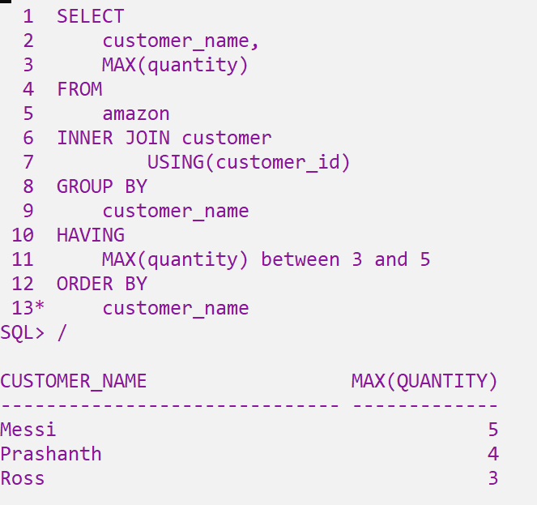

7) Display the customer along with the products whose purchase location is ‘Austria’

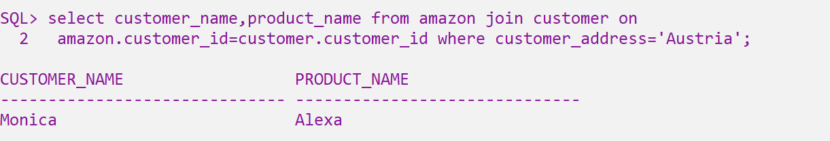

8) List the total quantity of products purchased from Amazon  
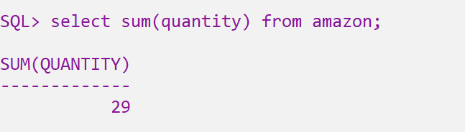

9) List the customers who are not dependent upon the products (i.e didn’t bought any products

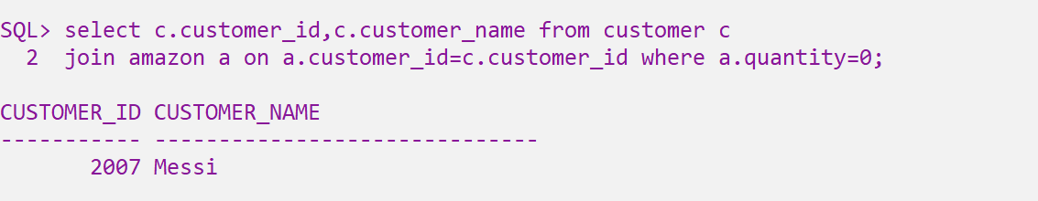

10) Display the customer name who bought minimum quantity of products

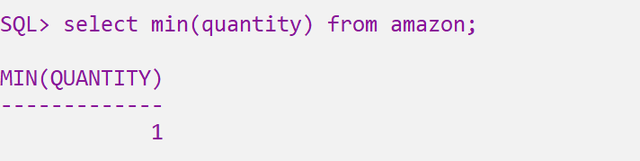  
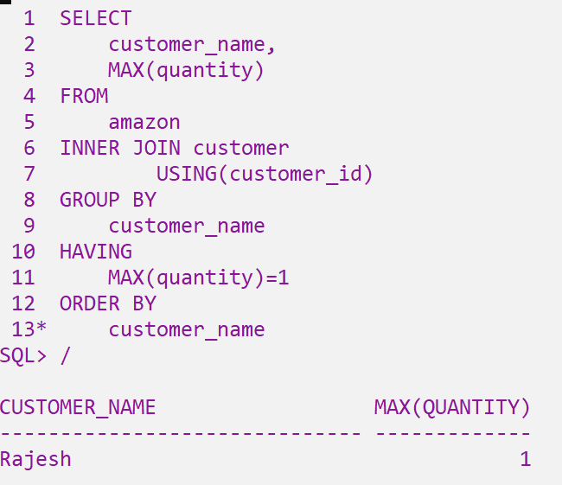

**Subquery**

1) List the name of the customer who brought any products from the shop.  
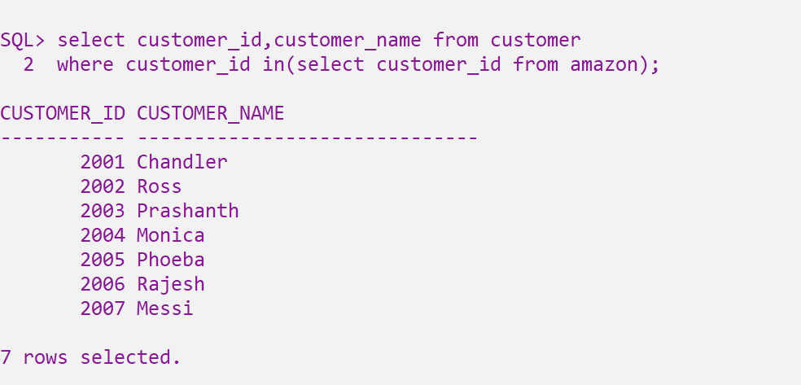

2) Find the product which is holds the highest price among the products.



3) List the customer 2007’s whose purchase is more expensive than the purchase of customer 2006’s

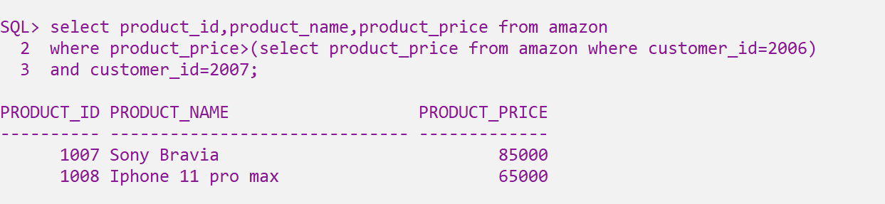

4) Display the customer name whose address are not functioning in

London.

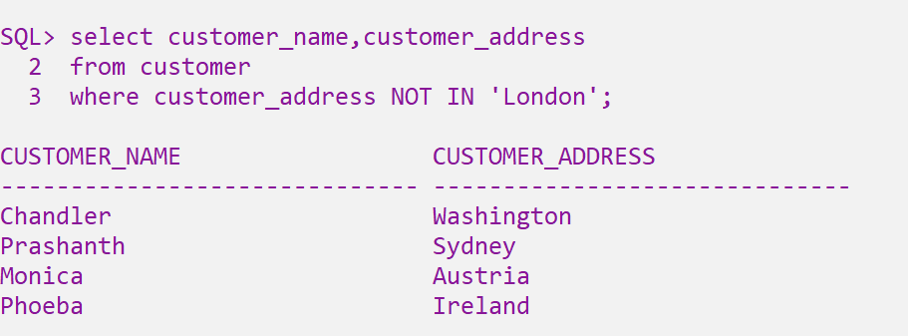

5) List the products which is sold for at-most 1 quantity  
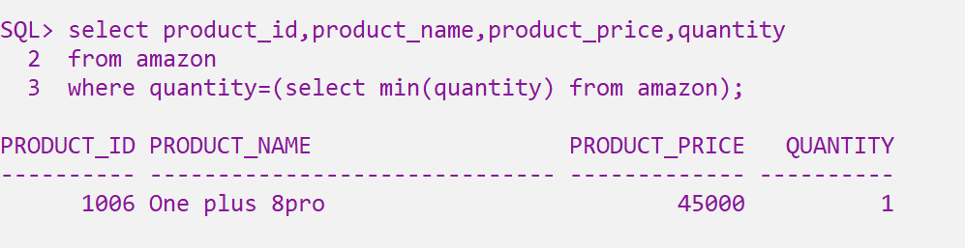

6) List the customer who didn’t buy even a single product  
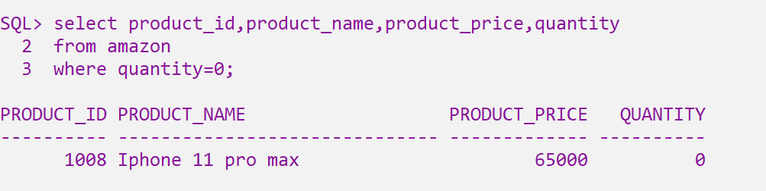

7) Find the product who is getting the minimum price among all of products.

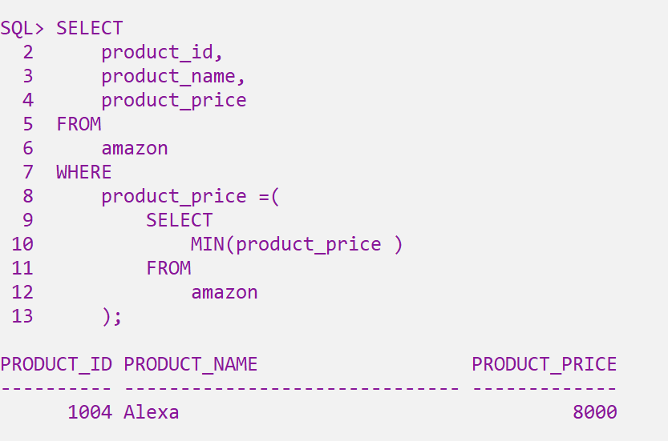

8) List the customer 2005’s whose purchase is more expensive than the purchase of customer 2001’s   
